COMP 3900 Assignment 1 Report

1. Statement of Requirements

The following are things the application is required to do:

* Allow user to login
* Allow user to create, view and edit timesheets
* Allow user to change password
* Allow admin to create, edit, update, and delete users

1. Use Case Diagram

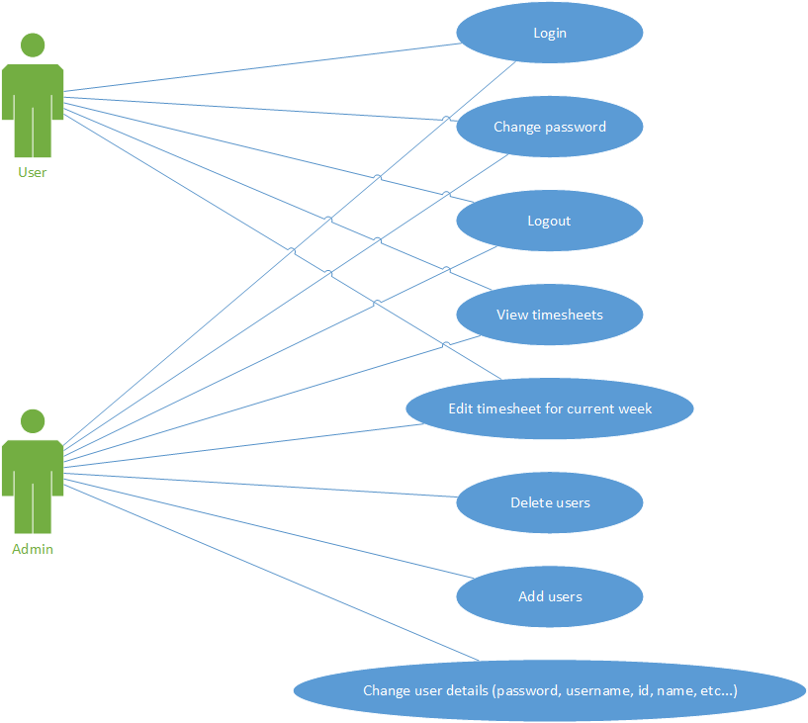

1. Test Plan

All core functionality listed in the requirements section are to be tested, every test should pass without error when following the test cases

1. Test Cases and Results

Test cases and results are shown in the following document. (Double click to open with Excel)



1. Building and Running Instructions
2. Import the COMP3900Assignment1 project into Eclipse
3. Import the timesheet project into Eclipse
4. Right-click the COMP3900Assignment1 project in the Pack Explorer and link the timesheet project in the Build Path and Deployment Assembly
5. Run the project
6. Open the page on Google Chrome, Edge, Firefox
   * Do NOT use Eclipse’s browser, as it does not render CSS properly